**CLASS 16/11/2021**

**UG SEM3**

**GRAPH THEORY**

**Bipartite graph:**  A graph G(V,E) is called bipartite if its vertex set V can be partitioned into two disjoint subsets V1 and V2 i.e. $V1∩V2=∅$ such that any edge e $∈$ E has one end vertex belong to V1 and other in V2 or vice versa .

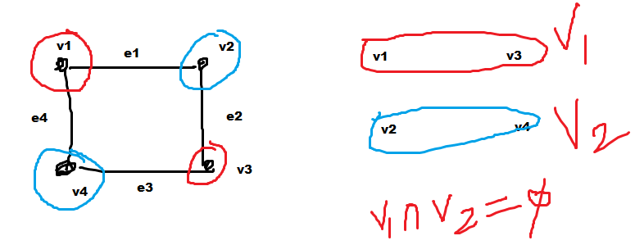

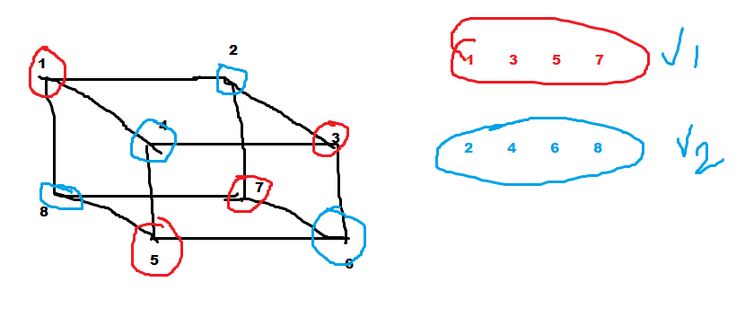

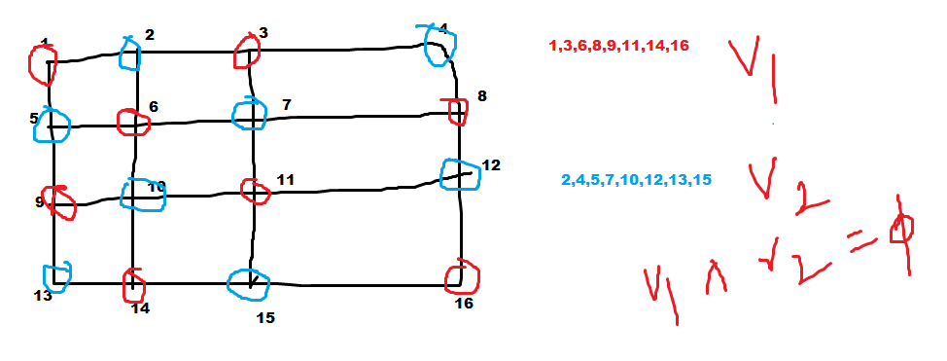

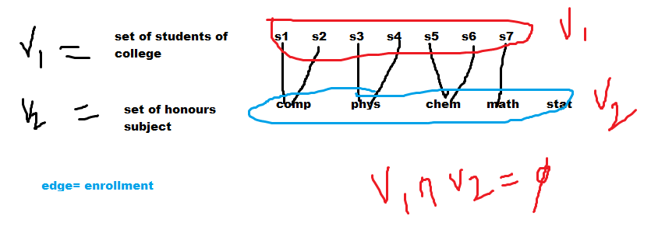

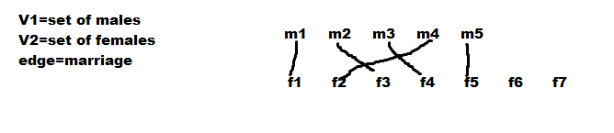

**Complete bi-partite graph: A bipartite graph G(V1,V2,E) is complete if any vertex in V1 is adjacent to every other vertices of V2 and vice versa.**

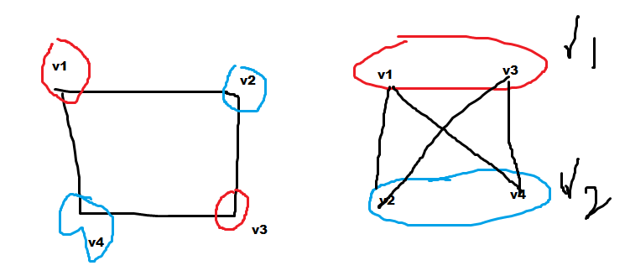

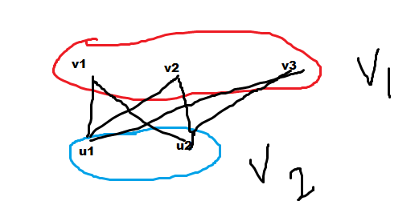

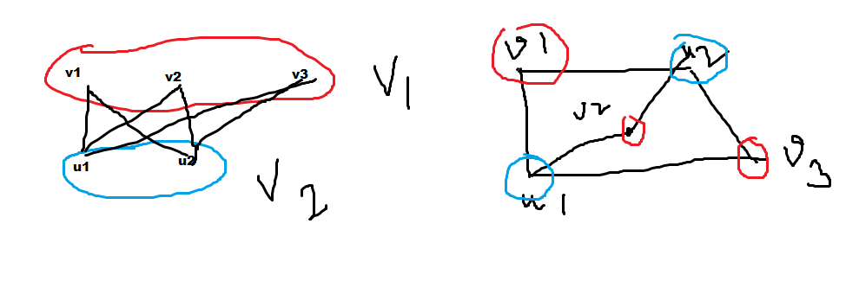

**Complement of a graph: A graph G’(V,E’) is complement of graph a G (V,E) , for any pair of vertices u,v $∈$ V if they are adjacent in G then they are not adjacent in G’ and vice versa.**

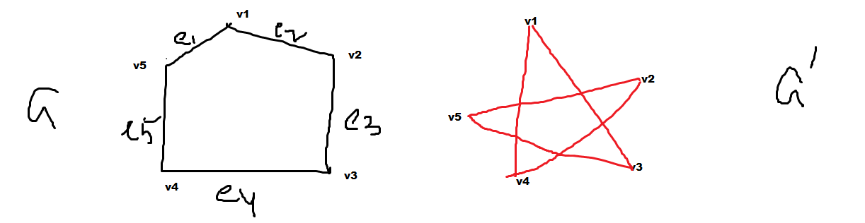

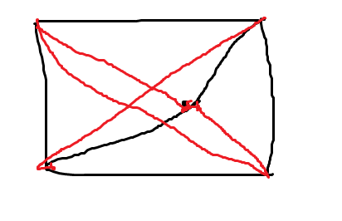

**Isomorphic Graph:** Two graphs are said to be isomorphic if they have same number of vertices and edges and there exists a one to one mapping between the vertices set of them such that incidence relationship is preserved.

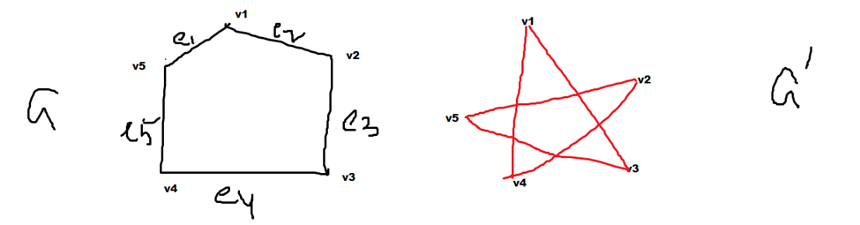

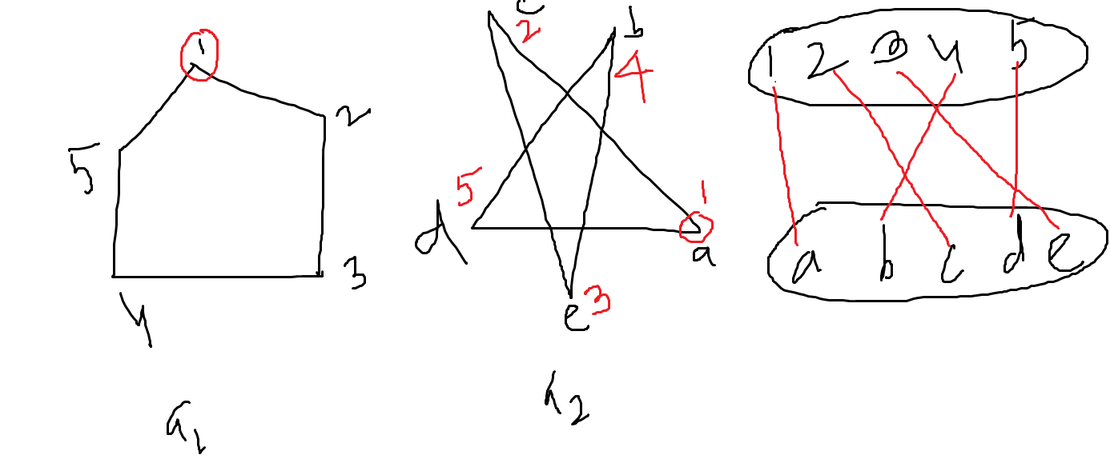



**Self – Complementary graph**

A graph G(V,E) is self-complementary if its complement G’ is isomorphic to G.



**Theorem: A self complementary graph has either 4m or 4m+1 vertices, where m=0,1,2,3…..**

Let us consider G(V,E) is a self-complementary graph.

So its complement G’(V,E’) is isomorphic with G(V,E).

So, |E|+|E’|= (1)

Now G and G’ are isomorphic

|E|=|E’|

So from equation (1)

|E|= (2)

|V| must be an positive integer and >0. Any positive integer can be represented as a series 4m,4m+1,4m+2,4m+3.

m=0 0,1,2,3

m=1 4,5,6,7

m=2 8,9,10,11

……

Replace |V|=4m then |E|=4m(4m-1)/4=m(4m-1)=integer

|V|=4m+1 then |E|=(4m+1)4m/4=(4m+1)m=integer

|V|=4m+2 then |E|=(4m+2)(4m+1)/4=(2m+1)(4m+1)/2=always fraction

|V|=4m+3 then |E|=(4m+3)(4m+2)/4=(4m+3)(2m+1)/2=always fraction

As number of edges |E| of a graph is always a positive integer, Hence |V| may have values either 4m or 4m+1 (Proved)

HT

**Theorem: Prove that a graph is bipartite if and only if all its cycles are of even length.**